AIM:

- Design FIR Low pass filter having cutoff frequency 3 KHz, N=31; Sampling frequency=10 KHz
- Design FIR High pass filter having cutoff frequency 3 KHz, N=31; Sampling frequency=10 KHz
- Design FIR Band pass filter having cutoff frequency (3 KHz, 6 KHz) N=31; Sampling frequency=10 KHz
- Design FIR Band stop filter having cutoff frequency (3 KHz, 6 KHz) N=31; Sampling frequency=10 KHz

CODE:

import numpy as np
import matplotlib.pyplot as plt
from scipy.signal import firwin, freqz

N = 31 # number of filter coefficients (taps) fs = 10000 # sampling frequency in Hz

# Function to display the frequency response of a filter def plot_response(h, fs, title):
w, H = freqz(h, worN=1024, fs=fs)

plt.figure(figsize=(10, 4))

plt.subplot(1, 2, 1) plt.plot(w, abs(H)) plt.title(title) plt.xlabel('Frequency (Hz)') plt.ylabel('Magnitude') plt.grid(True)

plt.subplot(1, 2, 2)
plt.plot(w, 20 * np.log10(abs(H) + 1e-10)) plt.title('Magnitude in dB') plt.xlabel('Frequency (Hz)') plt.ylabel('Magnitude (dB)')
plt.ylim(-100, 5) plt.grid(True)

plt.tight_layout() plt.show()

- FIR LOW PASS FILTER (CUTOFF = 3 KHZ)
cutoff = 3000
h_lp = firwin(N, cutoff, fs=fs) # hamming window is used by default

print("Filter coefficients:") print(np.round(h_lp, 4))

plot_response(h_lp, fs, 'FIR Low Pass Filter (Cutoff = 3 kHz)')

OUTPUT:
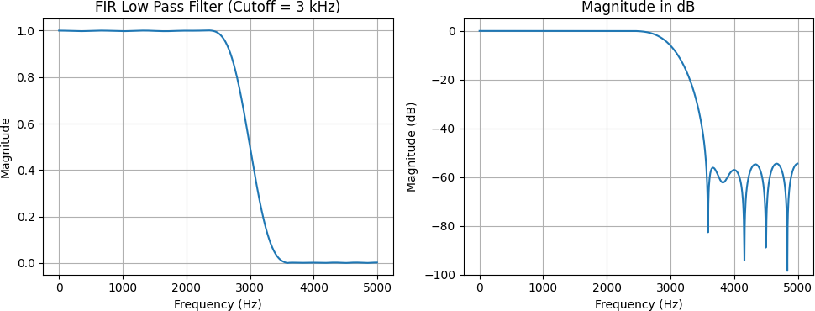

- FIR HIGH PASS FILTER (CUTOFF = 3 KHZ)
cutoff = 3000
h_hp = firwin(N, cutoff, pass_zero=False, fs=fs)

print("Filter coefficients:") print(np.round(h_hp, 4))

plot_response(h_hp, fs, 'FIR High Pass Filter (Cutoff = 3 kHz)')

OUTPUT:
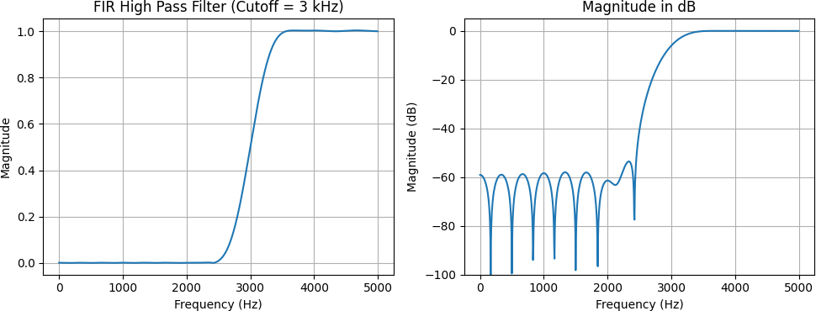

- FIR BAND PASS FILTER (CUTOFF = 3 KHZ, 6 KHZ)
Note: With fs = 10 kHz the Nyquist frequency is 5 kHz, so the upper cutoff of 6 kHz is not possible. The band 3 - 6 kHz is limited to 3 - 5 kHz, so the filter works as a high pass filter. A second design with fs = 20 kHz is given to show the real band pass filter.
# fs = 10 kHz : upper cutoff 6 kHz is above Nyquist (5 kHz), so only 3 kHz is used h_bp1 = firwin(N, 3000, pass_zero=False, fs=fs)

print("Filter coefficients (fs = 10 kHz):") print(np.round(h_bp1, 4))

plot_response(h_bp1, fs, 'Band Pass (3-6 kHz), fs = 10 kHz')

OUTPUT:
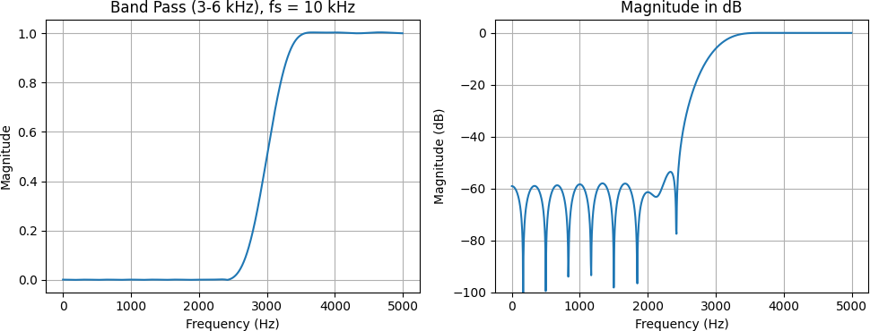

# fs = 20 kHz : both cutoffs 3 kHz and 6 kHz are valid fs2 = 20000
h_bp2 = firwin(N, [3000, 6000], pass_zero=False, fs=fs2)

print("Filter coefficients (fs = 20 kHz):") print(np.round(h_bp2, 4))

plot_response(h_bp2, fs2, 'FIR Band Pass Filter (3-6 kHz), fs = 20 kHz')

OUTPUT:
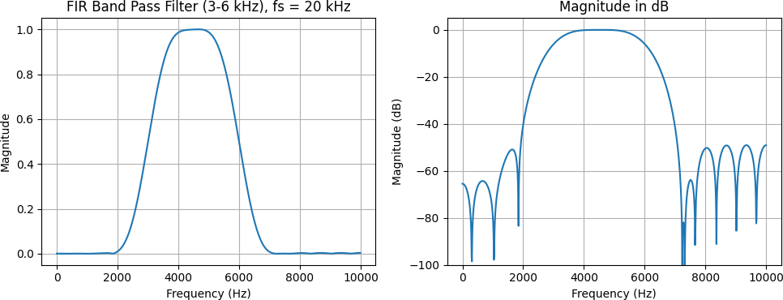

- FIR BAND STOP FILTER (CUTOFF = 3 KHZ, 6 KHZ)
Note: For the same reason, with fs = 10 kHz the stop band 3 - 6 kHz is limited to 3 - 5 kHz, so the filter works as a low pass filter. The real band stop filter is designed with fs = 20 kHz.
# fs = 10 kHz : upper cutoff 6 kHz is above Nyquist (5 kHz), so only 3 kHz is used h_bs1 = firwin(N, 3000, fs=fs)

print("Filter coefficients (fs = 10 kHz):") print(np.round(h_bs1, 4))

plot_response(h_bs1, fs, 'Band Stop (3-6 kHz), fs = 10 kHz')

OUTPUT:
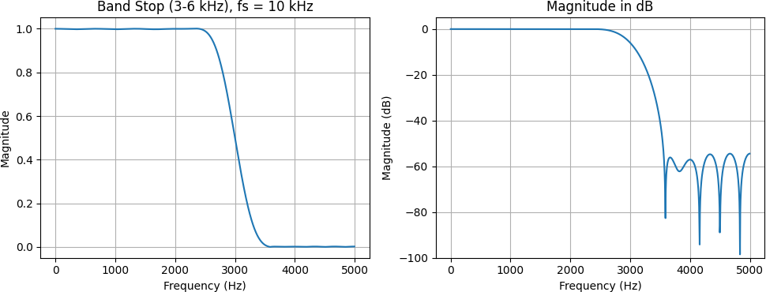

# fs = 20 kHz : both cutoffs 3 kHz and 6 kHz are valid fs2 = 20000
h_bs2 = firwin(N, [3000, 6000], fs=fs2) # pass_zero=True gives band stop

print("Filter coefficients (fs = 20 kHz):") print(np.round(h_bs2, 4))

plot_response(h_bs2, fs2, 'FIR Band Stop Filter (3-6 kHz), fs = 20 kHz')

OUTPUT:
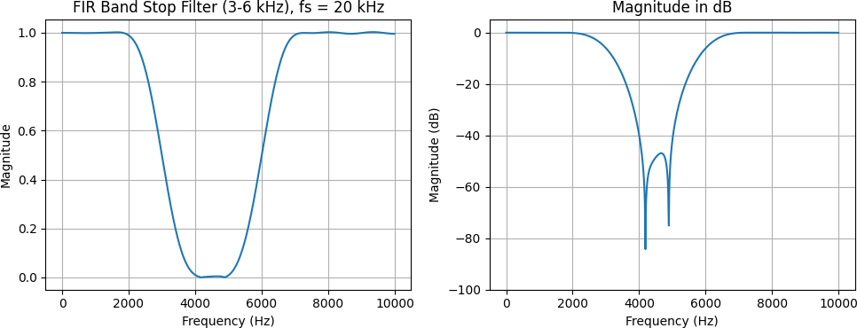

OBSERVATIONS:

The low-pass filter maintains unity gain (0 dB) up to approximately 2 kHz, drops to −6 dB at the 3 kHz cutoff, and provides over 54 dB attenuation beyond 4 kHz while maintaining linear phase. The high-pass filter attenuates frequencies below 2 kHz by more than 58 dB, reaches −6 dB at 3 kHz, and provides unity gain from 4 kHz to 5 kHz.

The band-pass filter behaves like a high-pass filter at (f_s = 10) kHz because the 6 kHz upper cutoff exceeds the Nyquist limit. At (f_s = 20) kHz, it successfully passes the 3–6 kHz range with at least 40 dB out-of-band attenuation. Similarly, the band-stop filter behaves like a low-pass filter at 10 kHz, while at 20 kHz it rejects the 3–6 kHz range, providing maximum attenuation of approximately 48 dB at 4.5 kHz.

Finally, the filter order (N = 31) results in a relatively wide transition band of about 1 kHz. Increasing the filter order would produce a sharper transition between the passband and stopband.

CONCLUSION:
Finite impulse response (FIR) low-pass, high-pass, band-pass, and band-stop filters were designed using the window method with 31 coefficients, and their frequency responses were analyzed through plots. The symmetric coefficients ensure linear phase in all four filters. However, a sampling frequency of 10 kHz limits the maximum representable frequency to 5 kHz (the Nyquist frequency). Therefore, a higher sampling frequency above 12 kHz is required to implement band-pass and band-stop filters with a 6 kHz cutoff.

